Assignment Questions:

1. Derive the cut-particle diameter of reverse flow cyclone separator based on the force balance across particles in swirling motion.
2. Air carrying particles of density 1800 kg/m3 and average diameter of 20 micron enters the cyclone separator at liner velocity of 18 m/s. Diameter of cyclone separator is 600mm. Specification of cyclone separator follow high efficiency stairmand design. Estimate the cut-particle diameter and what fraction of particles would be removed from the gas stream.
3. Gas stream carrying particles follow the rosin-ramler distribution with b = 0.307 and n =1.727 is passed through ESP to separate the particles. Particles collected at electrode plates also follows the R-R distribution with b = 0.224 and n = 1.116. If the overall efficiency is 80%, what is the cut particle diameter.
4. Following data was taken in a constant-pressure filtration of a slurry of CaCO3 in H2). Filter was a 6-in filter press with an area of 1 ft2. The mass fraction of solids in the feed was 0.139. Calculate α, Rm and cake thickness. Temperature is 700F.

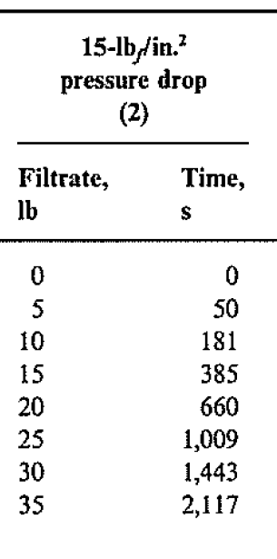

**Problem 4 is referred as Problem 30.4 in the below question.**

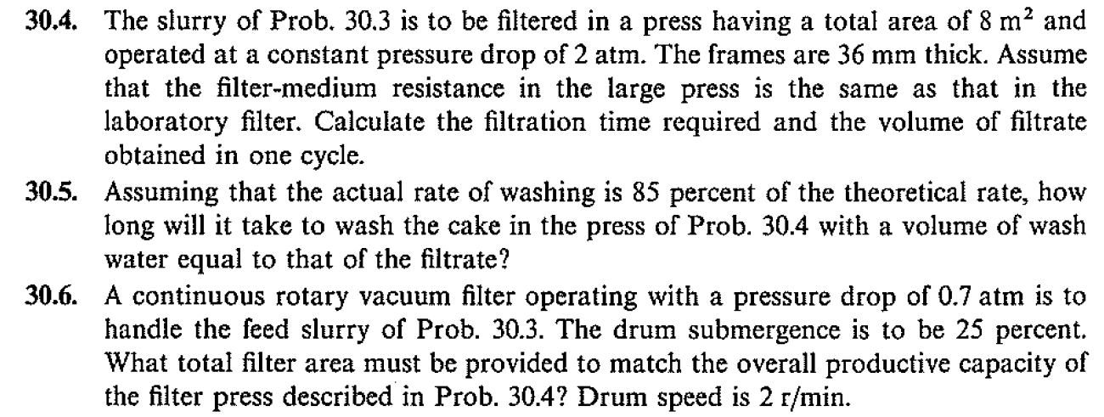

Last four questions taken from Mc Cabe and Smith book.

Instructions:

Hard copies to submitted by Monday (12-11-2023), 5.00PM in Room no -108, new Chemical Engineering Department (Annex building).

For solving Problem 3 and 4, graph paper should be used. Excel graphs are not accepted.